Washington Wizards Shot Analysis

Stat 345 Midterm Project

Charlie Handrick

Due April 1

# First Shot Chart

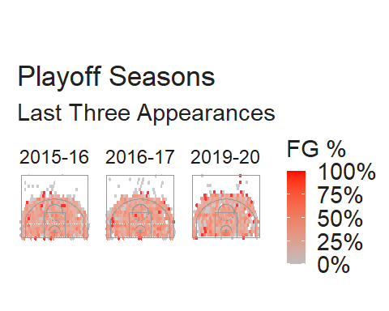

## Key Takeaways from Chart

* High paint scoring leads to success
* Poor Corner Threes percentages
* Corner mid range is a weapon of ours
* Apparent changes in personnel over the years.

### High Percentage Paint Scoring Leads to Success:

In all three playoff seasons it appears that as a team Washington shot well over 50% from the paint. This means that we were scoring easy buckets which often leads to a higher win rate. The reason we scored so much in the paint can also be the result of out rebounding the other team on offense. Second chance points are usually easier because the defender may still be in the air from the rebound. All in all, it appears that there is some correlation between paint scoring and playoff berth.

### Poor Three Point Shooting from the Corner:

In all three years our team shot very poorly from the corner. This does not reflect well on our franchise and teams can use this against us in the future. The corner three is often known as the easiest three points in basketball because it is the closest shot from the arch. Improvement in this area can help our team not only make the playoffs, but also have success in it.

### Strong Corner Mid Range Game:

Unlike our corner three shooting, the mid range from the corner has been a crucial weapon for our team in 2016/2017 and 2019/2020. This shot appears to be a dark red which indicates that we convert these shots at a very high rate. Our play makers in these two seasons felt very good about their ability to shoot from the mid range and it shows in the charts.

### Personell Turnover as Shown in Graphics:

The major difference that I can spot between the first two seasons (Middle and Left) versus last season is the loss of perennial all-star John Wall. Wall had a devastating drive and passing game. This is why the paint in the first two graphics is darker than the right. Wall would score almost at ease in the paint and it is apparent that our loss of him affected our teams post scoring.

# Second Shot Chart

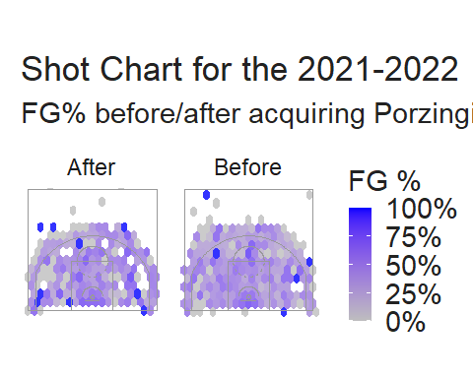

## Key Takeaways from Trade as Show by Graphic:

* Higher Paint FG%
* Improved Mid Range FG %
* Still no improvement in 3pt FG%

### Higher Paint Field Goal Percentage:

The acquisition of Kristaps Porzingis brought the presence of a Big Man that Washington has not had for years; With him being 7’3 it was apparent that this would be what he brought to our team. Looking at the right graphic before he arrived, there is a sole point right under the rim that stands out to the rest. Now, looking at the left graphic of when he arrived, it is seen that the whole lower paint is that shade earlier but darker. This means that he has made an impact not only with his game down low, but also his play making ability setting up other teammates for easy buckets.

### Improved Mid Range Shooting:

Kristaps may be tall, but he can also shoot lights out from the mid range. He made an immediate impact to a team that only has one other developed shooter, Bradley Beal. Kristap’s best shot arguably is a post up shot from the corner mid range and when looking at the left graphic, that is arguably the highest FG% look that Washington gets. Before he arrived the mid range game was non-existent, but he managed to add a crucial scoring option to the team.

### Lack of Three Point Production:

The main area that has lacked all year for Washington was not improved by this trade, the three ball. As seen in both graphs, with the exception of a few deep shots, it has been an abysmal season from deep. This is the result of all-star Bradley Beal sustaining a major injury earlier in the year, affecting overall production for him and the team. Kristaps and teammate Kyle Kuzma can shoot well from deep, however their shooting alone cannot make up for the poor shooting of the rest of the team.